**Laboratory of Natural Information Processing**

DA-IICT Gandhinagar

**DNA Pen**

**User Manual**



DNA Pen

**User Manual**

**© 2013 Manish K Gupta,**

**Laboratory of Natural Information Processing**

**DA-IICT, Gandhinagar, Gujarat 382007**

**http://www.guptalab.org/dnapen**

The software described in this book is furnished under an open source license agreement and may be used only in accordance with the terms of the agreement. Any selling or distribution of the program or its parts, original or modified, is prohibited without a written permission from

Manish K Gupta.

Documentation version 1.0

This file was last modified on May 12, 2013.

.

**Credits & Team**

***Principle Investigator:*** Manish K. Gupta, PhD.

***Graduate Advisor:*** Dixita Limbachiya

***Key Developers:*** Arnav Goyal* and Akshita Sahai*

***Supporting Developers***: Shikar Kumar Gupta, Sushant Pritmani & Foram Joshi

***Software Logo:*** Foram Joshi

* Key developers contributed equally to the project

**Acknowledgments**

We would like to thank fellow batch mates, Priyanka Shukla and Sonam Jain for providing us with the module to check the stability of a DNA Sequence

## **Table of contents**

## **General Information 03**

1. Introduction
2. Overview
3. Product Scope
4. Product Perspective

## **System Summary 04**

## **Getting Started 04**

1. Create New Brick
2. Free-hand Molecular Canvas
3. Digitized Molecular Canvas
4. Clear Grid
5. Save Brick Image
6. Save Brick Data

## **Support and Feedback 09**

## **References 09**

## **General Information**

1. Introduction

DNA is an ideal construction material for Nano-engineering. Due to its specificity of the base pairing, it weaves itself in to the target structures at nano level. DNA is a fundamental unit of any organism, which makes it the most intriguing and exciting option available for construction of nanostructure. DNA origami is a simple method used to construct complex two-dimensional (2D) and three-dimensional (3D) structures by DNA self-assembly. However, conducting random experiments for constructing such structures is exhausting and expensive, hence, there is need to develop the software for such nanoscale construction. DNA Pen is one such tool for creation of two dimensional DNA nanostructures which employs the idea of DNA Bricks. Desired shapes are created on the molecular canvas and the respective sequences required for the building of the shapes is generated as output. It checks for the thermo stability of the DNA nanostructures and avoid the unwanted hybridization. By the designing of the structures, visualizing the structure, the software increase the efficiency and productivity of the nano scale construction

1. Overview

DNA Pen has been primarily developed to facilitate the construction of nanostructures by DNA Self-assembly techniques. The software encourages the users to first visualize the structures, draw them accordingly on a virtual sheet and then generates the required DNA strand sequence. By this we not only achieve automation but also minimize the need for repetitive experimentation for developing one structure. The reduction in exhaustion is because of two processes that the software undertakes. The software is able to give infinite number of DNA strand sequences for the same shape. It allows user to choose to variety of DNA strands for the experiments.

1. Product Scope

This software provides the user with:

* Visualization and list of DNA strand sequences for DNA Bricks of different dimensions.
* Visualization and list of DNA Brick sequences for 2D structures drawn on a free-hand draw grid. (Each cell in the grid represents a DNA Brick of dimensions 3x7(nm) as default.)
* Visualization and list of DNA strand sequences for 2D structures drawn on a digital grid. (Each cell in the grid represents one tile of DNA Brick)
* DNA Pen checks for the thermal stability of the DNA strand sequences generated. Also it makes sure that there are no possibilities for any kind of secondary structures being formed. The strings then go through a refined process to ensure that they satisfy the constraints for error-correcting codes.

1. Product Perspective

This product’s main aim is to make the process of making the computerization and computation of DNA Origami structure user friendly.

## **System Summary**

Operating Systems – Windows 7, Mac OS X

This software requires the system to have specifications similar to: - 2.4 GHz Core 2 Duo, 100 MB Hard Disk, 2GB Random Access Memory and Basic peripherals like keyboard, mouse etc.

## **Getting Started**

Once you have successfully installed the software and you open DNA pen by double clicking on the icon available on your desktop screen, you will be view a window with four menu options on the menu bar. The main features that the software provides the user with, (and which are spanned across these four options on the menu bar are:-

* Create New Brick
* Work on Free-hand Molecular Canvas
* Work on Digitized Molecular Canvas
* Clear Grid
* Save Brick Image
* Save Brick Data
* Save Draw Data

1. Create New Brick

This option is available on the menu bar under the File menu. When the user clicks on **“File -> Create New Brick”** a small pop up window opens up where the user is required to fill in the height and width of the Brick that he is required to make. By default the values 3 x 7 (nm) will be filled in the text fields of the pop-up window. The pop-up has 2 buttons at the bottom of the window, the **“Save”** and the **“Cancel”** button. The function of these two buttons is self-explanatory. The Save button saves the dimensions of the brick created and now if the user works on the molecular canvas, the bricks used in the backed would be of the dimensions as specified by the user. Figure 1 shows the dialouge box appear when user wish to change the brick dimension.

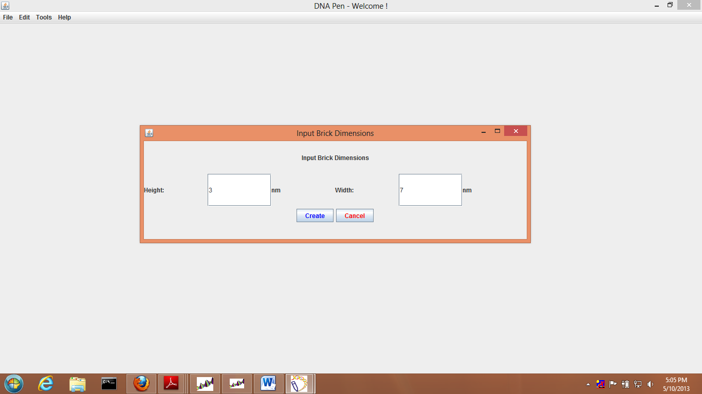

Figure 1: Input Brick Dimensions

1. Free Hand Molecular Canvas

This option is available under the tools menu of the menu bar. When the user clicks on **“Tools -> Free Hand Molecular Canvas”**, the display area on the DNA Pen’s home window would be filled up with a gridded canvas in which the user can draw the 2D structure he wants to create. Using this molecular canvas is very easy; a simple mechanism is to be followed. The user has to click and drag the mouse simultaneously on the canvas in accordance with the shape that he wants to create. Figure to is example of the hindi letter “aa” created on the free hand molecular canvas. User can draw any free hand shape he wishes to built at nano scale on this free hand molecular canvas.

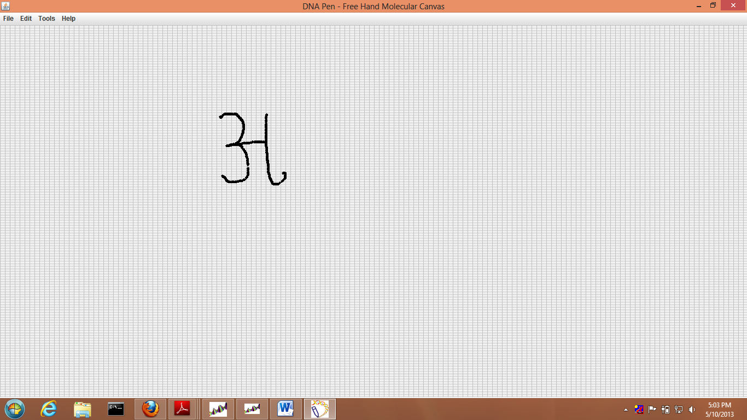

Figure 2 Free Hand Molecular Canvas

1. Digitized Molecular Canvas

This option is available under the tools menu of the menu bar. When the user clicks on the **“Tools-> Digitized Molecular Canvas”**, the display area on the DNA Pen’s home window would be filled up with a gridded canvas. Here the canvas would be filled with cells which are bigger in size as compared to the cells available in Free Hand Molecular Canvas. The user simply needs to click on the cell that he wants to be a part of his structure. The cell gets highlighted as the user clicks on it. Figure 3 is the example of the nano shape of smiley designed on the digitized canvas. There is an undo option available in the tools which enable the user to undo the designed once built. Also by clicking twice on the cell it will de-highlight the cell.

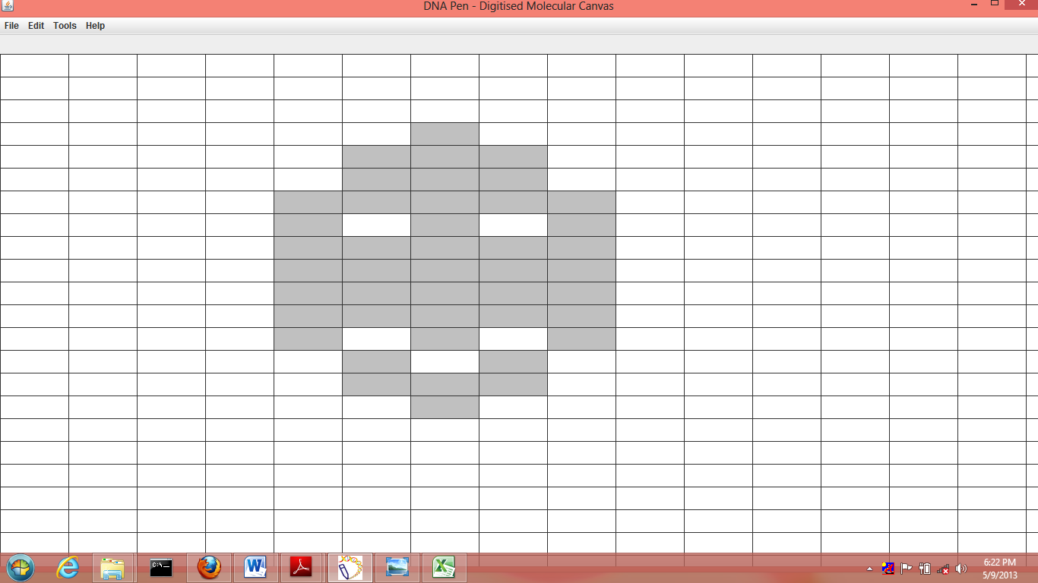

Figure 3: Digitized Molecular Canvas

1. Clear

The clear grid option is available under the tools menu of the menu bar.It will clear all the drawing on the canvas.

1. Save Brick Image

This option is available under the File menu of the menu bar. When the user clicks on **“File -> Save Brick Image”**, DNA Pen checks whether the user has created a new Brick and changed the dimensions from the default values. The software saves an image file of how the Brick logically looks like. A pop-up window is generated where in the user selects the location on their system where he want the image file to be saved at and gives a suitable name for the file. Again, this pop-up window has a **“Save”** button as well as a **“Cancel”** button which finally decides whether the file will be saved or not.

1. Save Brick Data

This option is available under the File menu of the menu bar. When the user clicks on **“File -> Save Brick Data”**, DNA Pen checks whether the user has created a new Brick and changed the dimensions from the default values. The software saves an excel file which contains an ordered list of the DNA strand sequences used to make the Brick. A pop-up window is generated where in the user selects the location on their system where he wants the excel file to be saved at and gives a suitable name for the file. Again, this pop-up window has a **“Save”** button as well as a **“Cancel”** button which finally decides whether the file will be saved or not.

1. Save Draw Data

This option is available under the File menu of the menu bar. When the user clicks on **“File -> Save Draw Data”**, DNA Pen checks whether the user has created a design on either of the two molecular canvases available. The software saves an excel file which contains an ordered list of the DNA strand sequences required to make such a structure experimentally. A pop-up window is generated where in the user selects the location on their system where he wants the excel file to be saved at and gives a suitable name for the file. Again, this pop-up window has a **“Save”** button as well as a **“Cancel”** button, which finally decides whether the file will be saved or not. Figure 4 shows the way to save the designed shape, which will generate the sequence to for the designed shape.

1. Output

Once you save the draw data, the output generated is in the excel format. The destination place which you have selected to save the draw data, contains the excel file. Double click on the file to open it. It gives the information about the base sequences required for the shape designed. Also it includes the sequences for each domain in the DNA bricks, number of full and half tile for each domain and number of stick ends. It generates the coordinates for each base in the sequence on the basis of shape constructed on the molecular canvas. Figure 5 show the sample output file for the above shape mentioned in the digitized molecular canvas. This output helps the researcher to design the shape with respect to arrangement of bricks DNA and the stick ends.

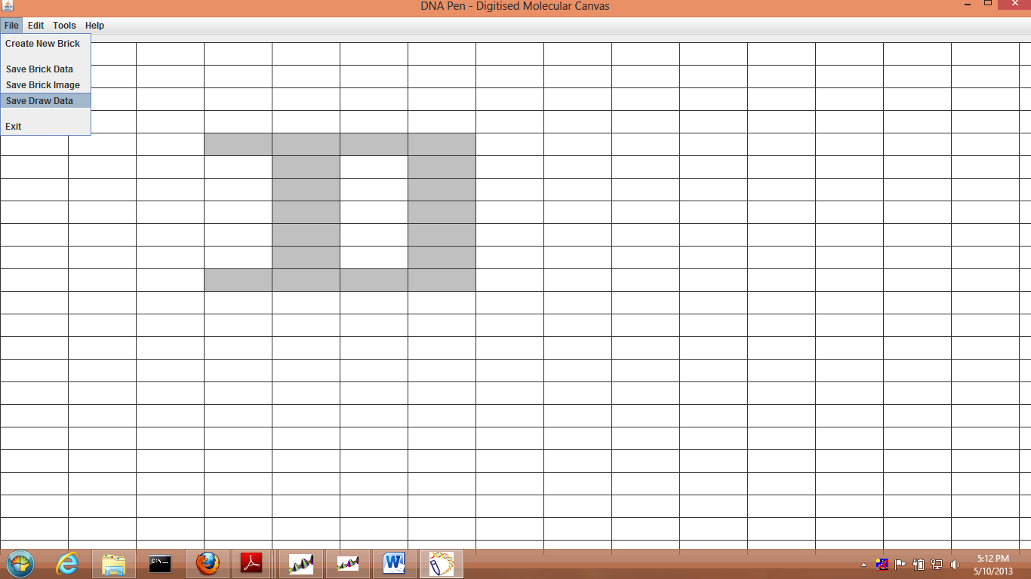Figure 4 Save the Draw Data

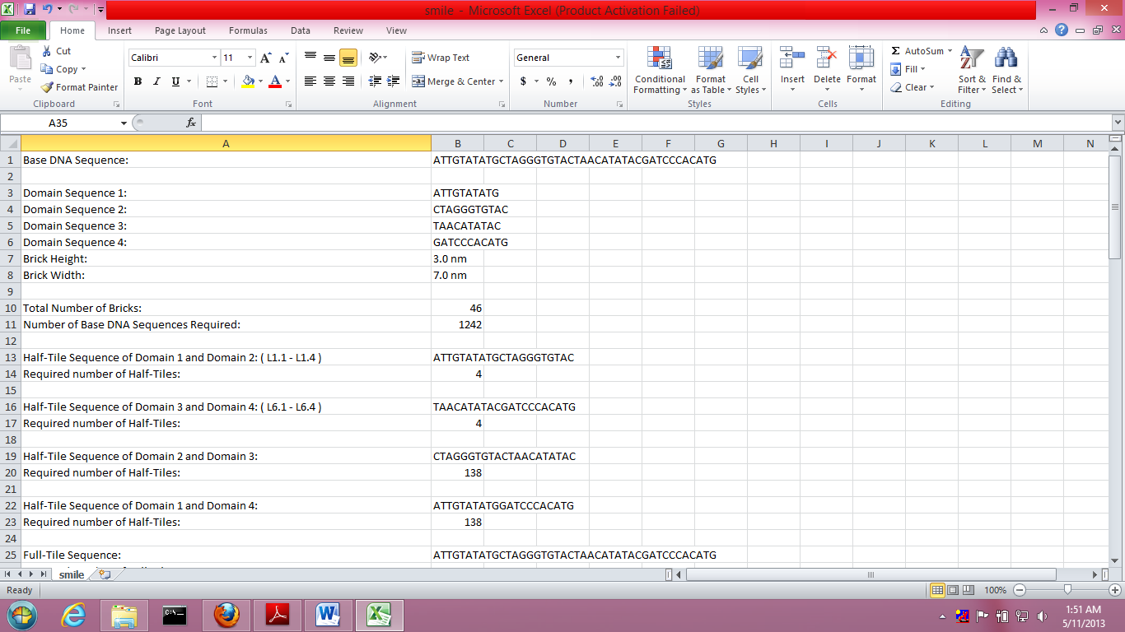

Figure 5 Sample output file

**Help Menu**

“Help” menu which is very common in any software. There are four options in the Help Menu.

1. User Manual

2. Product Demo

3. Product Feedback

4. About

* First option, user manual should open this user manual in the default pdf reader of user’s system.
* Second option product demo will open the homepage of DNA Pen where the demo is available.
* Third option will open the feedback form where you can give feedback for the software.
* Finally about option recognize the contributors in this project. There is a dialog box that opens up as shown below, which contains information like logo of the software, version of the software, name of the software, Credits button and URL of the software. On pressing “Credits”, it opens a PDF document in user’s default PDF reader.

## **Support and Feedback**

Users are requested to contact Manish K. Gupta at the email: mankg@computer.org for feedback and any other issues with the software. Two platform specific installers (Windows and Mac) are available on the project home page along with source code with open source license agreement.

## **References**

[1] Bryan Wei, Mingjie Dai and Peng Yin, Complex Shaped Self-Assembled from Single-Stranded DNA Tiles, Nature 2012, vol 485, pages 623-626.

[2] Yonggang Ke, Luvena L. Ong, William M. Shih and Peng Yin, Three-Dimensional Structures Self-Assembled from DNA Bricks, Science 2012, vol 338, pages 1177-1183.

[3] Carlos Ernesto Castro, Fabian Kilchherr, Do-Nyun Kim, Enrique Lin Shiao, Tobias Wauer, Philipp Wortmann, Mark Bathe and Hendrik Dietz, A Primer to Scaffolded DNA Origami, Nature Methods 2011, vol 8:3, pages 221-229.

[4] Olgica Milenkovic and Navin Kashyap, DNA Codes that Avoid Secondary Structures, International Symposium on Information Theory (ISIT) 2005, pages 288-292